Date: 08.08.2025
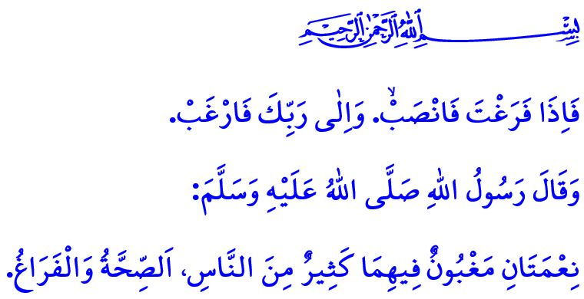holiday blessed through silat al-rahim
Dear Muslims!
Our sublime religion, Islam, calls upon us to live our lives without forgetting the wisdom behind our creation and the purpose of our existence. It commands us to act at all times with the awareness that we are in the presence of our Lord, as stated in the verse, وَهُوَ مَعَكُمْ اَيْنَ مَا كُنْتُمْۜ “And He is with you wherever you are.”
Dear Believers!
One of the areas in which Islam calls for attentiveness is work and rest. According to our religion, rest is just as important as work. Our Almighty Lord draws our attention to this truth with His words: “... and made your sleep for rest, and made the night as a cover, and made the day for livelihood” Therefore, a Muslim also has need of rest, mental and physical renewal, spiritual cleansing, and spending quality time with their family. However, let us not forget that a Muslim’s work, rest, holidays, and entertainment must all remain within legitimate, moral, and halal bounds. Even while resting, a Muslim should not waste time but must always preserve a sense of servitude and responsibility. As I recited at the beginning of the khutbah, Allah the Almighty conveys this truth in the verse: فَاِذَا فَرَغْتَ فَانْصَبْۙ. وَاِلٰى رَبِّكَ فَارْغَبْ “So once you have fulfilled ˹your duty˺, strive ˹in devotion˺, turning to your Lord ˹alone˺ with hope.”
Esteemed Muslims!
The Almighty Allah describes the qualities of the believers in the Holy Qur’an, stating: “Successful indeed are the believers: those who humble themselves in prayer; those who avoid idle talk...” This divine admonition reminds us to dedicate our lives to actions that are beneficial both for this world and for the Hereafter.
Unfortunately, some holiday organizations today have taken a form that disregards the rulings of Allah the Almighty, lacks sensitivity toward what is halal and haram, reaches extremes in luxury and extravagance, and knows no limits in carnal desires and indulgences. Such an understanding of holiday has absolutely no place in our religion.
In truth, a holiday should not be a time of idleness, laziness, or heedlessness; rather, it should be transformed into a fruitful opportunity for rest through varied and beneficial activities. It should serve as an occasion to contemplate the might and power of the Almighty Lord through travelling across the earth, and to observe the universe with eyes of reflection and wisdom. A holiday undertaken with this awareness is not merely a time for rest but also an opportunity for learning and worship.
Dear Believers!
A holiday presents an invaluable opportunity to introduce our children to our hometowns and villages, as well as to the historical and natural beauties of our heavenly country, kneaded by the blood of our martyrs. A holiday offers a wonderful chance to earn the blessings of our parents and to reconnect with our relatives. For parents who long for their children and grandchildren and await their return, it is also a source of great joy. Today, many mothers and fathers are longing for their children, and many grandparents are awaiting the return of their grandchildren. There are countless elders who yearn for a few words, a greeting, or a moment of affection. The most important duty a Muslim must fulfill after obedience to Allah the Almighty is to serve their parents and to meet all their material and spiritual needs. It is to never abandon them to loneliness or neglect, but rather to win their hearts. Indeed, our Prophet’s (saw) warning in this regard is very clear: “The pleasure of your Lord lies in the pleasure of your parents, and the anger of your Lord lies in their anger.”
Dear Muslims!
Holidays are periods of time that provide opportunities for our children’s religious, social, and cultural development, as well as for strengthening the bonds of kinship (silat al-rahim). The Messenger of Allah (saw) says: “Whoever wishes for abundant provision and a blessed life, let them maintain the ties of kinship.” Therefore, let us also visit our parents and relatives during holidays. Let us not neglect our religious, moral, and social responsibilities. Let us not turn our holidays into times when we forget our servitude to Allah and open the door to sin.

Let us let the closing of our words be the hadith I recited at the beginning of this khutbah: “There are two blessings which many people fail to make the most of: health and free time.”

Hadid, 57/4.
Naba, 78/9-11.
Sharh, 94/7-8.
Mu’minun, 23/1-3.
Tirmidhi, Birr, 3.
Bukhari, Adab, 12.
Bukhari, Riqaq, 1. General Directorate of Religious Services

